David L. Suddjian
Biological Consulting Services

801 Monterey Avenue, Capitola, CA 95010
Telephone 831· 479· 9603, email dsuddjian@aol.com

Summary of 2007
Corvid Monitoring Surveys

In The Santa Cruz Mountains

Prepared for

Command Oil Spill Trustee Council

Prepared by

David L. Suddjian
Biological Consulting Services
801 Monterey Ave., Capitola, CA 95010

February, 2008
Final Report

INTRODUCTION

In 2002 David Suddjian (unpubl. data) conducted a pilot study in Big Basin Redwoods State Park, Portola Redwoods State Park, Butano State Park, and San Mateo County Memorial Park (Figure 1) to compare relative abundance of corvids in areas of high human use with those well removed from areas of high use. In 2003 the Command Oil Spill Trustee Council (COSTC) initiated a corvid monitoring program in the same four parks that was patterned closely the 2002 effort (Suddjian 2004). The COSTC study was to assist the Council in restoration planning for potential projects benefiting the Marbled Murrelet (Brachyramphus marmoratus), including corvid management. This report presents the results of corvid monitoring surveys conducted in 2007.

Corvids are among the most significant predators on eggs and chicks of marbled murrelets (Nelson 1997, Peery et al. 2004). Both Steller’s Jay (Cyanocitta stelleri) and Common Raven (Corvus corax) have been documented to prey on murrelet eggs or chicks in the Santa Cruz Mountains (Singer et al. 1991, Suddjian 2003, 2003b, Perry et al. 2004), and Peery et al. (2004) demonstrated rates of nest predation as high as 61-87% in the region.

The Steller’s Jay has apparently always been a prominent member of the avian community in old growth forests of the Santa Cruz Mountains. In contrast, Common Ravens are relatively new in those forests, and have only become numerous since the 1980s (Figures 2 and3; Kelly et al. 2002, Bousman 2007). Both species are attracted to campgrounds and other areas of parks with high human use, where human food is often readily available. Consequently, previous studies and general observations in the Santa Cruz Mountains have typically found both Steller’s Jay and Common Raven to be much more numerous at campgrounds than away from campgrounds. A third species of corvid, American Crow (C. brachyrhynchos), has been recorded only twice in the areas encompassed by this study, both times at Big Basin. One was shot at Huckleberry Campground on April 6, 2005 (P. Halbert pers. comm.). Another flew over the park headquarters area on February 27, 2008 (D. Suddjian pers. obs.). These are the only records of crows from the interior part of Big Basin Redwoods State Park (they are rare non-breeding visitors coastward at the park’s Rancho Del Oso unit), and crows do not yet occur at the other three parks.

This study compares corvid populations in murrelet nesting habitat within campgrounds (treatment areas) to corvid populations in such habitat in areas located >300 meters from campgrounds (control areas). It also provides a baseline from which to judge future changes in numbers related to corvid management projects in the parks. Such projects were initiated in 2005.

Methods

Study Design

The 2002 pilot study sampled corvids in nine treatment areas and 19 control areas within the four parks and on adjacent private forest land (D. Suddjian unpubl. data). The monitoring program initiated by COSTC in 2003 established and surveyed one or more treatment and control areas in each park in 2003, except at Memorial, where no suitable control areas were identified (Table 1, and Figures 3 to 6). All of the treatment and control areas selected for the COSTC study overlapped entirely or partially with areas surveyed by Suddjian in 2002. Surveys in 2003 to 2007 sampled seven treatment areas and 12 control areas. All survey areas are in coast redwood (Sequoia sempervirens) forest known to support use by Marbled Murrelets, with nesting known or suspected to occur either in or immediately adjacent to each survey area. They range in size from 3.2 to 15.7 hectares (Table 1). Trees with potentially suitable nest platforms (Pacific Seabird Group 2003) were counted in each survey area to provide a measure of the habitat quality of each site for murrelets (Table 2).

Control areas are located a minimum of 300 meters from any campground, picnic area, or residential community, and are located along roads or trails to facilitate access. Treatment areas include standard campgrounds and their immediate surroundings. Group campgrounds were excluded because they were irregularly occupied, and they were often smaller than a minimum size criterion of 3.0 hectares (Suddjian 2004).

Management projects were initiated in 2005 in the three state parks to attempt to reduce corvid populations. These include direct removal of ravens, increased emphasis on proper food storage, increased education for park users about Marbled Murrelets and about corvids as predators, and warnings and citations for campers feeding wildlife or improperly storing food or trash.

Description of Survey Areas

General Patterns Of Human Use

The campgrounds are used continuously throughout the survey period of June to August, although occupancy varies daily and through the season. Occupancy is typically at or near 100% on weekends, but often considerably less on weekdays, and is greater in July and August than in June. Campground occupancy during the surveys in 2007 ranged from 8% to 89% (Table 3). Overall occupancy for all sites combined was up 5% in 2007, the first between-year increase since the study began. Average occupancy was up 10-22% for the four Big Basin campgrounds in 2007, but was similar to occupancy in 2006 in the other parks.

Human foods are continually available to corvids in varying degrees at occupied campgrounds. Food is occasionally (but regularly) offered directly to wildlife by campers, but is also widely available as discarded or fallen scraps or fragments, garbage left at camp sites, food fragments stuck on grills at fire rings, and at water spigots where dishes are rinsed. Food left unattended during the day or improperly stored at night is commonly plundered by wildlife. Additionally, in some parks food is readily available at trash receptacles that permit animal access, spillage by animals, are left open, or are too full to close properly. Another human-related food source, although more rarely available than human food, was road killed mammals, such as squirrels, raccoons and skunks.

Human activity in the control areas is mostly limited to hiking, bike riding and jogging, with no established picnic sites. Although each control area receives daily use by people in June to August, no one other than the surveyor were evident during any of the morning surveys in control areas in 2003 to 2007, with the exception of one park maintenance vehicle that drove through once at one site in 2005, and one jogger at one site in 2006.

Big Basin Redwoods State Park

Treatment areas are Blooms Creek Campground (55 sites), Sempervirens Campground (31 sites), Huckleberry Campground (71 sites), and Wastahi Campground (27 sites) (Table 1, Figure 4). Two control areas are located along the upper reach of Opal Creek, and four are along Gazos Creek Escape Road west of Opal Creek (Table 1, Figure 4).

In 2007 the campgrounds had new metal trash dumpsters with heavy metal lids. These replaced dumpsters with plastic lids or rusted holes that had allowed animal access. The lids on the new dumpsters were usually closed, but rarely were left open, and occasionally (following weekends) the lid of an overly full dumpster could not be closed, permitting birds and other animals to reach its contents.

Portola Redwoods State Park

The treatment area is the main campground, referred to here as Portola Campground (53 sites; Table 1, Figure 5). The control areas are along Peters Creek north of the campground, and in two areas along the Iverson Trail (Table 1, Figure 5).

The campgrounds and picnic areas at Portola have metal trashcans with animal proof lids. Rarely overfull trashcans had garbage spilled outside, but usually there was no spillage observed around the garbage receptacles in Portola, and none was evident during visits in 2007.

Butano State Park

The treatment area is the Ben Ries Campground (38 sites; Table 1, Figure 6). The control areas are along the Butano Service Road extending northeast from the campground, Goat Hill Trial, and Doe Ridge Trail (Table 1, Figure 6).

Ben Ries Campground has animal-proof metal trashcans. No animal access to the cans or spillage around the cans was observed in 2007.

San Mateo Memorial County Park

The treatment area is the Sequoia Flat Campground (104 sites) (Table 1, Figure 7). No control areas with suitable habitat and sufficient distance from areas of high human use were identified, so control areas for this park were located in Big Basin instead (four areas along Gazos Creek Escape Road, Figure 4).

In 2007 Sequoia Flat Campground had replaced its old open metal trash cans with six animal proof trashcans and 16 metal dumpsters with plastic lids. The dumpsters were of two sizes, and the lids on the smaller size dumpsters were light enough for raccoons to open them. This was observed on day Suddjian was present in the camp in 2007. For example, during the July 25 dawn murrelet survey, Suddjian observed the same raccoon move through the camp and flip lids open on six dumpsters over a 58 minute period. The lids were also sometimes left open by campers. Once open, the raccoon or other mammals pulled trash out of the dumpsters, or corvids could enter the dumpsters to scavenge.

CoRvid Survey Methods

Each site was surveyed using the total area search method (Ralph et al. 1993). The search area at treatment areas included the entire area of campsites and extended outward 50 meters from the edge of the camp boundary. Control areas were established along roads and trails, and the search area extended outward for 50 meters from the center of the road or trail. Thus, the control areas were equivalent to 100-meter wide strip transects in which the total area searches were conducted. Fifty meters was selected as the outside distance to insure the best chance of visual detection of perched, silent birds. Vegetation obscured views too significantly beyond 50 meters. Movement off the road or trail was avoided in control areas to minimize noise made by the surveyor.

David Suddjian conducted all the surveys. Surveys were done by walking slowly through the survey site and pausing often for brief periods, listening for vocalizations and making visual scans to detect corvids. Although Luginbuhl et al. (2001) found that broadcasting taped calls enhanced detections of ravens, this method was not used in this study to avoid disturbance of campers and distraction to the surveyor when campers would inquire about the broadcast calls. Furthermore, the taped calls might attract ravens into the survey areas from outside the boundary during the survey.

Each jay and raven was recorded, indicating its age if known. Aging of ravens was straightforward through the season due to the status of molt of adults, feather wear, vocalizations, and the presence of a pale gape on the juveniles. Aging of jays was easy in June and most of July (using plumage pattern, begging behavior and vocalizations, and the pale gape of the juveniles), but it became more difficult in late July and August, when the juveniles more closely resembled adults and begging activity declined. Aging silent jays was sometimes difficult due to poor lighting conditions. Behavior of jays and ravens was recorded in notes, particularly as it related to foraging.

Other information recorded for each survey included date, start and end times, weather conditions, number of occupied campsites, number of opportunities to access human food (i.e., spilled trash, unattended food, campers feeding wildlife), and details of foods consumed by corvids.

Survey Frequency and Timing

Four surveys were conducted at each site, with one survey in June, two in July, and one in August. Survey dates in 2007 for each site are given on Table 4. Each site was surveyed only once per day (or if surveyed more than once per day, then data from the first survey of the day was used for analyses here), but usually more than one site was surveyed on the same morning. Campgrounds were only surveyed on weekdays. An effort was made to sample each site on dates close to those when it was sampled in prior years.

Each survey occurred in a window beginning 35 minutes after sunrise and extending for up to four hours after sunrise. The rationale for selection of this window of time for the surveys was described in Suddjian (2004). The time required to cover each survey area varied with the size of the area, but the average rate of coverage was 3.1 minute per ha (± 0.6 minute). The time expended in each area was kept fairly consistent over each of the four replications, and each year.

Analyses

Analyses comparing abundance in treatment and control areas used only the maximum number of corvids detected on any of the four surveys of each area (Luginbuhl et al. 2001), although average counts are also presented in the tables. Both adult and juvenile corvids were lumped for analyses of overall abundance. Numbers of adult and juvenile jays were analyzed to evaluate changes in abundance of each age class over time. Adjusted counts of adults and juvenile jays were derived from the raw counts using the percentage of juveniles observed during each survey replication in each park field. Values of p < 0.05 were considered statistically significant, while values 0.1> p > 0.5 were considered marginally significant.

Some comparisons are made to the results of the preliminary study of 2002 (D. Suddjian unpubl. data) for all sites pooled together, as the sites were either the same as those of the COSTC-sponsored surveys, or overlapped with them broadly, and the surveys methods were the same.

Results

Steller’s Jay

Survey results and statistical comparisons for each park in 2007 are given on Tables 5 and 6. Raw counts for 2003 to 2007 are given in Appendix 1. Adjusted counts of adults and juveniles are given in Appendix 2. Steller’s Jays were recorded at all survey sites. They were recorded on all surveys in treatment areas, and on 81% of 48 surveys in control areas (Table 5). They were ubiquitous in treatment areas, where overall they were 7.6 times more numerous than in control areas, with the difference being highly significant (Table 6). The higher numbers in treatment areas compared to controls was significant for each park except Butano, where low numbers of jays at Ben Ries Campground were only slightly greater than numbers in the control areas (Table 5, Appendix 1).

Overall, Steller’s Jay abundance (all parks combined) was lower in 2007 than in the preceding years of the study, decreasing by 23% from 2006 (Table 9, Figure 8). A negative trend for treatment areas from 2003 to 2007 (r² = 0.817) was significant (p = 0.018), with jay abundance decreasing by 54% over the 5-year period. A negative trend for control areas (r² = 0.901) was also significant (p = 0.007), with jay abundance decreasing by 38% over the 5-year period.

Over 2003-2007, the total number of jays in treatment and control areas was significantly correlated (r² = 0.958, p = 0.002). The ratio of jays in treatment and control areas decreased from 10.2:1 in 2003 to 7.6:1 in 2007, with a marginally significant trend (r² = 0.587, p = 0.065). Changes in absolute numbers in control areas were small.

Among individual parks, the 5-year trend in total jay abundance showed significant declines in treatment areas at Portola (r² = 0.792, p = 0.022), Butano (r² = 0.788, p = 0.022) and Memorial (r² = 0.698, p = 0.039), and a nearly significant decline at Big Basin (r² = 0.343, p = 0.108) (Figure 9). The trend was significant in control areas only at Butano (r² = 0.518, p = 0.085) (Figure 9).

Jays remained most abundant at Memorial in 2007, where they were two to ten times more numerous than at the other parks; abundance in the treatment areas in the three state parks was similar at Big Basin and Portola, but lower at Butano (Figure 10). The maximum raw count for any area in 2007 was 104 jays at Sequoia Flat Campground at Memorial on August 21, 2007. Jay numbers generally increased over the season, but peak numbers were recorded at four of seven campgrounds in late July rather than August (Table 5). There was no consistent pattern of seasonal change in the various control areas (Table 5), but pooled together, jay abundance peaked in early July.

The percentage of juvenile jays in the overall study area has consistently exhibited an increase across the survey season, but with the percentage continuing to rise markedly in treatment areas, but with relatively small increases in control areas (Figure 11). This apparently reflects a movement of jays into the campgrounds from outlying areas, perhaps from significant distances. Substantial numbers of juvenile jays congregate in some campgrounds (notably Sequoia Flat, Blooms Creek and Huckleberry). An increase in adult jays in treatment areas from June to late July suggests a similar movement may occur for adults, but to a lesser degree (Figure 12).

The annual maxima for adult jays in treatment areas in all parks combined exhibited a significant decline over the five-year period, with numbers in 2007 being the lowest for this study (r² = 0.871, p = 0.010; Figure 13a). However, adults in control areas showed a non-significant declining trend (Figure 13b).

For individual parks, adult jays exhibited significant declines at Butano (r² = 0.943, p = 0.003; Figure 14c) and Memorial (r² = 0.773, p = 0.025; Figure 14d), and a marginally significant decline at Big Basin (r² = 0.614, p = 0.059; Figure 14a). The decline at Portola was nearly significant (r² = 0.458, p = 0.105; Figure 14b). The same pattern of decline in adults was evident when five-year trend analyses were limited just to the results of the June surveys, the period which most closely reflects the population of jays actually nesting in the treatment areas. Significant declines in June were evident at Big Basin, Butano and Memorial, and all parks combined, but not Portola (Figure 15). A significant decline in adults in control areas was only observed at Butano (r² = 0.677, p = 0.043).
In contrast to trends for adult jays, the five-year trend for juvenile jays was not significant in either treatment or control areas (Figures 13 and 14).

Absolute numbers of adult and juvenile jays were far greater at Big Basin and Memorial, than at Portola and Butano (Figure 16), reflecting the much larger campground areas in the former two parks.

Jay behavior and interactions with people were similar to those observed in previous years (Suddjian 2004, 2005a, 2005b, 2008). Jays were frequently seen inspecting occupied campsites for food, and were quick to capitalize on opportunities to steal unattended food, or to search for food in just-vacated sites. Jays were observed taking advantage of spilled garbage, stealing unattended food in camps, being fed directly by campers, and picking food fragments from campfire grills and at water spigots. Human foods taken by jays during the surveys were similar to those mentioned in Suddjian (2004).

Jays typically began each morning with an active search of campsites for food scraps left from the previous night, and visited trash receptacles where nocturnal mammals had made food available (primarily at Memorial Park). Places where jays consistently sought and found scraps of food were at the campsite tables, grills of campsite fire rings, and at campground water spigots where campers rinse their dishes. Some individuals spent considerable time foraging by digging into the dirt and duff at campsites and consuming small items of undetermined identity. Natural foods frequently taken by jays in campgrounds included huckleberries and acorns of tanoaks. Young jays were especially attracted to ripening huckleberries.

Common Raven

Survey results and statistical comparisons for each park in 2007 are given on Tables 7 and 8. Raw counts for 2003 to 2007 are given in Appendix 1. Common ravens were recorded in all seven of the treatment areas in 2007, where they were detected on 86% of the 28 surveys (Table 7). In contrast, they were detected at six (50%) of the 12 control areas, and detected on only 19% of 48 surveys (Table 7). Raven numbers in treatment areas exceeded those in control areas by 4.1 times when the data from all sites were pooled (Table 8). For individual parks, ravens were significantly more numerous in treatment areas than control areas at Portola, Big Basin, and Memorial. The difference was not significant at Big Basin (Table 8).

Common Ravens increased in overall abundance in both treatment and control areas from 2006 to 2007 (Figure 17). Taken individually, they increased in treatment areas in all four parks, but increased in control areas only at Big basin and Portola (Figure 18). However, the changes in absolute numbers were small (Appendix 1), and mostly reflected specific locations of nesting pairs and increases in numbers of juveniles produced in 2007.

There were a non-significant flat trends for the period 2003 to 2007 for all treatment areas combined (r² = 0.08, p = 0.319) and all control areas (r² = 0.01, p = 0.442). Among individual parks, there were no significant trends for the five-year period for either treatment or control areas (Figure 18).

Ravens were generally uncommon, and no large groups were observed in 2007. Most surveys recorded only one or two adults, and more rarely three to five adults. Raven numbers did not increase consistently over the season among the sites (Table 7). Most treatment sites had one pair (occasionally two pair) of adults that was regularly or irregularly present, and in some cases their offspring. The only aggregation observed other than pairs or families was recorded during a murrelet survey at Memorial Park on June 13, when five adults flew down the Pescadero Creek drainage, apparently leaving a roost near Wurr Flat Group Camp.

At Big Basin there were approximately 11 pairs of ravens in the general region of the park containing the survey areas, plus additional single birds. Productivity was good, with at least nine pairs fledging two or three juveniles each, for a total off at least 22 juveniles. Family groups with fledglings (first evident on July 3) were at: Blooms Creek Campground, Huckleberry Campground, Wastahi Campground, east of Sempervirens Campground, at three places near Opal Creek from Gazos Creek road to 100 Acre Woods, near Sempervirens Reservoir, and near Ocean View Summit.

At Portola one pair of ravens nested 0.25 miles south of park headquarters (and a similar distance from the main campground), fledging two juveniles on July 11. This was the only pair present in the area of the park covered by this study during most of the season. But on August 21 another pair with three juveniles was also at the campground; these may have moved to the area after nesting elsewhere.

At Butano there were two pairs of ravens in the area of the park covered by this study, with both nesting successfully. A pair nested northeast of the campground and fledged two juveniles by July 1. Another pair (sometimes accompanied by a third adult) may had its nest site farther northeast up the Little Butano Creek drainage, fledging three juveniles before July 23.

At Memorial at least six pairs of ravens nested in or near the park in 2007, with at least five of these pairs fledging a total of at least 11 juveniles (the first on or before June 14). One pair nested in Sequoia Flat Campground, with two other pairs located west and east of that camp. Other nesting pairs were in the area of Wurr Flat Group and Tan Oak Picnic Area. park. At least two pairs fledged young, first evident on July 10.

Raven behavior and interactions with people were similar to those described previously (Suddjian 2004 and 2005a). As in prior years, they remained wary and did not approach people or take handouts. But they regularly investigated campsites when people were absent, visited spilled garbage, and stole unattended food. The concentration of naïve fledgling jays at campgrounds continued to attract attention from ravens, and seemed to be a principal attraction for them at campgrounds.

Discussion

Steller’s Jay decreased in 2007, and jays showed declining populations over the 2003-2007 period reported here, with significant trends for all parks combined, and for Portola, Butano and Memorial. The trend at Big Basin was nearly significant. Changes were most pronounced in treatment area, and were primarily due to declining numbers of adults, with no trend for numbers of juveniles. The lack of a corresponding decrease in juveniles may reflect the concentrating effect that the campgrounds have, attracting sufficient numbers of juveniles to may mask changes in that segment of the population.

The small number of jays recorded in some campgrounds suggests that the paradigm of campground attraction for corvids is not always upheld. For example, the high count of jays at heavily-used Ben Ries Campground in Butano in 2007 was only six birds! And several counts there this year found only 3-4 jays. Counts of 9-10 jays at the larger Portola Campground were also strikingly low. These low counts (in some cases even when the campground was nearly full of campers) suggest that improved garbage management and user education has had positive benefits.

In contrast to the jay, Common Raven showed no significant trends for the 2003-2007 period. Ravens increased in 2007 after two years of decreases, reaching numbers that were nearly as high as any year of this study. Productivity was also high.

Continued efforts at park user education, and improved garbage receptacles has reduced the amount of human foods available to corvids since the study began. However, a ongoing problem in garbage management at Big Basin continued in 2007: it was not uncommon for an overfull dumpster to be left full for more than one day, permitting wildlife access to the contents. The replacement of open trash cans with lidded dumpsters at Memorial was a significant improvement in 2007, but the lids on the smaller dumpsters did not weigh enough to prevent raccoons from opening them, so trash remained available to wildlife.

Literature Cited

Bousman, W. G. 2007. Breeding Bird Atlas of Santa Clara County, California. Santa Clara Valley Audubon Society. 547 pp.

Kelly, J. P., K. L. Etienne and J. E. Roth. 2002. Abundance and distribution of the common raven and American crow in the San Francisco Bay Area, California. West. Birds 33:202-217.

Luginbuhl, J. M., J. M. Marzluff, J. E. Bradley, M. G. Raphael, and D. E. Varland. 2001. Corvid survey techniques and the relationship between corvid relative abundance and nest predation. Journal of Field Ornithology 72:556-572.

Nelson, S. K. 1997. Marbled Murrelet (Brachyramphus marmoratus). No. 276 in The birds of North America (A. Poole and F. Gill, Eds.) Acad. Of Nat. Sci., Philadelphia, Pennsylvania, and the Amer. Orn. Union, Washington D.C.

Pacific Seabird Group. 2003. Methods for surveying Marbled Murrelets in forests: a revised protocol for land management and research. Marbled Murrelet Technical Committee. Unpubl. report dated 6 January, 2003.

Peery, M. Z, S. R. Beissinger, S. H. Newman, E. B. Burkett, and T. D. Williams. 2004.
Applying the declining population paradigm: diagnosing causes of poor reproduction in
the marbled murrelet. Conservation Biology 18:1088-1098.

Powell, H. 2005. The accidental reaper – ravens are following people into new habitats. California Wild. Summer 2005. California Academy of Sciences.

Ralph, C. J., Geupel, G. R., Pyle, P., Martin T. E. and D. F. DeSante. 1993. Handbook of field methods for monitoring landbirds. Gen. Tech. Rep. PSW-GTR-144. Pac. Southwest Res. Station, Forest Service, U.S.D.A.

Singer, S. W., Naslund, N. L., Singer, S. A., and C. J. Ralph. 1991. Discovery and observation of two tree nests of the Marbled Murrelet. Condor 93: 330-339.

Suddjian, D. L. 2003. Summary of 2002 Marbled Murrelet monitoring surveys
at Big Basin and Portola State Parks. Unpubl. report. Prepared for the California Dept. of Fish and Game.

Suddjian, D. L. 2004. Summary of 2003 corvid monitoring surveys in the Santa Cruz Mountains. Unpubl. report prepared for the Command Oil Spill Trustee Council.

Suddjian D. L. 2005a. Summary of 2004 corvid monitoring surveys in the Santa Cruz Mountains. Unpubl. report prepared for the Command Oil Spill Trustee Council.

Suddjian D. L. 2005b. Summary of 2005 corvid monitoring surveys in the Santa Cruz Mountains. Unpubl. report prepared for the Command Oil Spill Trustee Council.

Suddjian, D. L. 2008. Summary of 2006 corvid monitoring surveys in the Santa Cruz Mountains. Unpubl. report prepared for the Command Oil Spill Trustee Council.
Table 1. Attributes of the corvid survey areas.

Human Area Slope Approx. Canopy Composition³

Survey Area Type Use Access¹ (ha) Position² Elevation RW DF TO FLO MA Other

Big Basin Redwoods SP
Blooms Creek Treatment Camp 1 15.7 B 900–1,120’ 1 2 1 2 3 3
Sempervirens Treatment Camp 1 7.2 B 960-1,080’ 1 2 1 2 3 --
Huckleberry Treatment Camp 1,2 13.4 B 980-1,160’ 1 2 1 1 2 --
Wastahi Treatment Camp 1,3 7.2 B 1,020-1,250’ 1 2 1 -- -- --
Opal Creek 2 Control Hiking 1 10.2 B 1,050-1,180’ 1 2 1 3 3 3
Opal Creek 3 Control Hiking 3 6.6 B 1,075-1,225’ 1 2 1 3 3 3
Gazos Creek Road 1 Control Hiking 2 9.4 S 1,120-1,280’ 1 2 1 2 2 --
Gazos Creek Road 2 Control Hiking 2 6.7 S 1,240-1,350’ 1 1 1 2 2 --
Gazos Creek Road 3 Control Hiking 2 7.5 S 1,140-1,320’ 1 2 1 2 2 --
Gazos Creek Road 4 Control Hiking 2 7.5 S 960-1,180’ 1 2 1 2 2 --

Portola Redwoods SP
Portola Treatment Camp 1 8.4 B 350-560’ 1 2 1 1 3 3
Peters Creek Control Hiking 1,3 7.7 B 400-600’ 1 2 1 2 3 3
Iverson Trail 1 Control Hiking 3 7.1 B 320-520’ 1 2 1 2 2 3
Iverson Trail 2 Control Hiking 2,3 6.9 B 350-520’ 1 2 1 3 3 3

Continued on next page,

Table 1, continued

Human Area Slope Approx. Canopy Composition³

Survey Area Type Use Access¹ (ha) Position² Elevation RW DF TO FLO MA Other

Butano SP
Ben Ries Treatment Camp 1,3 9.6 B 400-650’ 1 2 1 3 3 --
Butano Service Road Control Hiking 2 8.1 B 500-670’ 1 2 1 3 3 3
Goat Hill Trail Control Hiking 3 3.2 S 620-840’ 1 2 1 2 3 --
Doe Ridge Trail Control Hiking 3 15.7 S 880-1,120’ 1 1 1 2 3 --

Memorial CP
Sequoia Flat Treatment Camp 1 12.6 B 180-280’ 1 2 1 2 -- 3

1. Access: 1 (paved road), 2 (unpaved road), 3 (trail).
2. Slope position: B (bottom of valley), S (mid-slope), R (ridgeline).
3. Approximate canopy cover by each tree species, classed as 1 (50-100%), 2 (11-49%), 3 (1-10%). Tree species: RW (coast redwood), DF (Douglas-fir), TO (tan oak), FLO (Forest (Shreve) live oak), MA (madrone), other (includes California bay, red alder, white alder, and big leaf maple)
Table 2. Number of trees with platforms in each survey area¹.

Area # # # # RW # DF # All

Survey Area (ha) RW² DF All / ha / ha / ha

Big Basin
Blooms 15.7 11 38 49 0.7 2.4 3.1
Sempervirens 7.2 7 16 23 1.0 2.2 3.2
Huckleberry 13.4 28 31 59 2.1 2.3 4.4
Wastahi 7.2 9 8 17 1.3 1.1 2.4
Opal 2 10.2 16 11 27 1.6 1.1 2.7
Opal 3 6.6 6 12 18 0.9 1.8 2.7
Gazos 1 9.4 11 13 24 1.2 1.4 2.6
Gazos 2 6.7 10 9 19 1.5 1.3 2.8
Gazos 3 7.5 13 3 16 1.7 0.4 2.1
Gazos 4 7.5 7 4 11 0.9 0.5 1.5

Portola
Portola 8.4 21 33 54 2.5 3.9 6.4
Peters 7.7 4 22 26 0.5 2.9 3.4
Iverson 1 7.1 16 29 45 2.3 4.1 6.4
Iverson 2 6.9 11 18 29 1.6 2.6 4.2

Butano
Ben Ries 9.6 17 44 61 1.8 4.6 6.4
Service 8.1 3 20 23 0.4 2.5 2.8
Goat Hill 3.2 2 8 10 0.6 2.5 3.1
Doe Ridge 15.7 9 25 34 0.6 1.6 2.2

Memorial
Sequoia 12.6 39 45 84 3.1 3.8 6.7

1. “Platforms” were features in the live crown of a conifer that offered potentially suitable nest sites for Marbled Murrelets; “a relatively flat surface at least 10 cm (4 in) in diameter and 10 m (33 ft) high” Pacific Seabird Group (2003, p. 2).

2. “RW” (coast redwood), “DF” (Douglas-fir).
Table 3. Campground occupancy (%) during the 2003 - 2007 corvid surveys.

Survey Area # Sites Run 1 Run 2 Run 3 Run 4 Avg
03 04 05 06 07 03 04 05 06 07 03 04 05 06 07 03 04 05 06 07 03 04 05 06 07

Big Basin
Blooms 55 73 67 44 51 60 76 75 36 60 85 80 55 71 64 80 75 71 53 69 67 75 67 53 61 73
Sempervirens 31 61 65 52 29 42 87 87 16 58 77 94 61 65 58 84 74 74 65 65 48 79 72 49 52 63
Huckleberry 71 54 37 48 35 42 86 80 21 31 58 55 38 39 35 56 70 52 37 66 52 66 52 36 42 52
Wastahi 27 22 11 7 11 22 67 56 26 26 74 26 26 22 15 30 56 26 15 37 59 43 30 18 22 46

Portola
Portola 53 25 17 13 21 25 83 28 23 15 8 47 25 21 32 28 23 26 25 21 21 44 24 20 22 20

Butano
Ben Ries 38 50 57 79 26 21 64 93 61 97 89 100 100 96 76 66 79 100 93 92 87 73 88 82 73 66

Memorial
Sequoia 104 25 36 25 24 20 42 74 59 24 20 100 28 56 40 37 46 33 37 28 38 53 43 44 29 29

All Areas 379 42 40 36 29 33 69 70 37 40 50 75 41 51 45 52 56 49 43 50 50 61 50 42 41 46
Combined
Table 4. Dates of the 2007 corvid surveys.

Survey Dates

Survey Area Run 1 Run2 Run 3 Run 4

Big Basin
Blooms Creek June 20 July 3 July 19 August 17
Sempervirens June 20 July 3 July 19 August 17
Huckleberry June 20 July 3 July 19 August 17
Wastahi June 20 July 3 July 19 August 17
Opal Creek 2 June 18 July 5 July 17 August 17
Opal Creek 3 June 18 July 5 July 17 August 16
Gazos Creek Road 1 June 19 July 6 July 18 August 16
Gazos Creek Road 2 June 19 July 6 July 18 August 16
Gazos Creek Road 3 June 19 July 6 July 18 August 16
Gazos Creek Road 4 June 19 July 6 July 18 August 16

Portola
Portola June 27 July 11 July 27 August 22
Peters Creek June 27 July 12 July 27 August 22
Iverson Trail 1 June 26 July 11 July 26 August 22
Iverson Trail 2 June 26 July 11 July 26 August 22

Butano
Ben Ries June 12 July 1 July 23 August 8
Butano Service Road June 12 July 2 July 24 August 8
Goat Hill Trail June 12 July 2 July 24 August 8
Doe Ridge Trail June 12 July 2 July 24 August 8

Memorial
Sequoia Flat June 14 July 10 July 25 August 21

Table 5. Number of Steller’s Jays per hectare on the 2007 surveys.

Survey Area Run 1 Run 2 Run 3 Run 4 Max Avg

Big Basin
Blooms 1.08 1.72 2.93 1.59 2.93 1.83
Sempervirens 1.25 1.39 2.08 1.11 2.08 1.46
Huckleberry 2.01 2.46 3.96 1.42 3.96 2.46
Wastahi 0.56 0.42 1.25 0.97 1.25 0.80
Opal 2 0.49 0.20 0.39 0.00 0.49 0.27
Opal 3 0.30 0.30 0.30 0.30 0.30 0.30
Gazos 1 0.00 0.21 0.32 0.11 0.32 0.16
Gazos 2 0.15 0.00 0.15 0.00 0.15 0.07
Gazos 3 0.27 0.00 0.13 0.13 0.27 0.13
Gazos 4 0.53 0.13 0.53 0.13 0.53 0.33

Portola
Portola 1.07 1.31 2.26 2.62 2.62 1.82
Peters 0.39 0.39 0.00 0.13 0.39 0.23
Iverson 1 0.42 0.28 0.70 0.56 0.70 0.49
Iverson 2 0.29 0.43 0.43 0.58 0.58 0.43

Butano
Ben Ries 0.31 0.73 0.42 0.63 0.73 0.52
Service 0.12 0.37 0.00 0.12 0.37 0.15
Goat Hill 0.31 0.63 0.00 0.63 0.63 0.39
Doe Ridge 0.19 0.13 0.13 0.00 0.19 0.11

Memorial
Sequoia 1.83 4.84 5.40 8.25 8.25 5.08

Table 6. Comparison of numbers of Steller’s Jays in treatment and control areas in 2007.

Statistical
Survey Area Avg/ha¹ S.E. N Significance

All parks combined
Treatment 3.1 2.50 7 P^{(1-tailed)} < 0.001
Control 0.4 0.18 12

Big Basin
Treatment 2.6 1.16 4 P^{(1-tailed)} < 0.001
Control 0.3 0.14 6

Portola
Treatment 2.6 0.00 1 P^{(1-tailed)} = 0.004
Control 0.6 0.16 3

Butano
Treatment 0.7 0.00 1 P^{(1-tailed)} = 0.162
Control 0.4 0.22 3

Memorial
Treatment 8.3 0.00 1 P^{(1-tailed)} < 0.001
Control² 0.3 0.16 4 ²see note

- Average of maximum counts from each survey area.
2. Controls for Memorial CP were located in Big Basin Redwoods SP.

Table 7. Number of Common Ravens per hectare on the 2007 surveys.

Survey Area Run 1 Run 2 Run 3 Run 4 Max Avg

Big Basin
Blooms 0.13 0.25 0.25 0.13 0.25 0.19
Sempervirens 0.14 0.00 0.00 0.14 0.14 0.07
Huckleberry 0.30 0.37 0.37 0.00 0.37 0.26
Wastahi 0.28 0.00 0.56 0.14 0.56 0.24
Opal 2 0.00 0.00 0.00 0.10 0.10 0.02
Opal 3 0.30 0.15 0.61 0.00 0.61 0.27
Gazos 1 0.00 0.00 0.00 0.00 0.00 0.00
Gazos 2 0.00 0.00 0.00 0.00 0.00 0.00
Gazos 3 0.00 0.00 0.00 0.13 0.13 0.03
Gazos 4 0.00 0.00 0.00 0.00 0.00 0.00

Portola
Portola 0.12 0.36 0.48 0.24 0.48 0.30
Peters 0.00 0.00 0.00 0.00 0.00 0.00
Iverson 1 0.14 0.00 0.00 0.00 0.14 0.04
Iverson 2 0.14 0.14 0.00 0.00 0.14 0.07

Butano
Ben Ries 0.10 0.21 0.52 0.42 0.52 0.31
Service 0.00 0.00 0.00 0.00 0.00 0.00
Goat Hill 0.00 0.00 0.00 0.00 0.31 0.08
Doe Ridge 0.00 0.00 0.00 0.06 0.06 0.02

Memorial
Sequoia 0.56 0.32 0.40 0.56 0.56 0.46

Table 8. Comparison of numbers of Common Ravens in treatment and control areas in 2007.

Statistical
Survey Area Avg/ha¹ S.E. N Significance

All parks combined
Treatment 0.41 0.16 7 p^{(1-tailed)} < 0.001
Control 0.10 0.17 12

Big Basin
Treatment 0.33 0.18 4 p^{(1-tailed)} = 0.107
Control 0.14 0.24 6

Portola
Treatment 0.48 0.00 1 p^{(1-tailed)} < 0.027
Control 0.10 0.20 3

Butano
Treatment 0.52 0.00 1 p^{(1-tailed)} = 0.003
Control 0.02 0.04 3

Memorial
Treatment 0.56 0.00 1 p^{(1-tailed)} = 0.027
Control² 0.03 0.07 4 ²see note

- Average of maximum counts from each survey area.
- Controls for Memorial CP were located in Big Basin Redwoods SP.

Table 9. Number of corvids per hectare in treatment and control areas in the four parks from 2002 to 2007.

Species 2002¹ 2003 2004 2005 2006 2007

Steller’s Jay
Treatment areas 5.39 ± 1.53 6.79 ± 3.65 4.46±2.90 4.37±3.87 4.05±1.98 3.12±2.50
Control areas 0.61 ± 0.29 0.66 ± 0.32 0.53±0.26 0.48±0.36 0.45±0.42 0.41±0.18

Common Raven
Treatment areas 0.55 ± 0.25 0.22 ± 0.17 0.43±0.24 0.28±0.23 0.23±0.10 0.41±0.16
Control Areas 0.09 ± 0.07 0.09 ± 0.14 0.06±0.10 0.01±0.04 0.06±0.12 0.10±0.17

- 2002 surveys (D. Suddjian unpublished data)

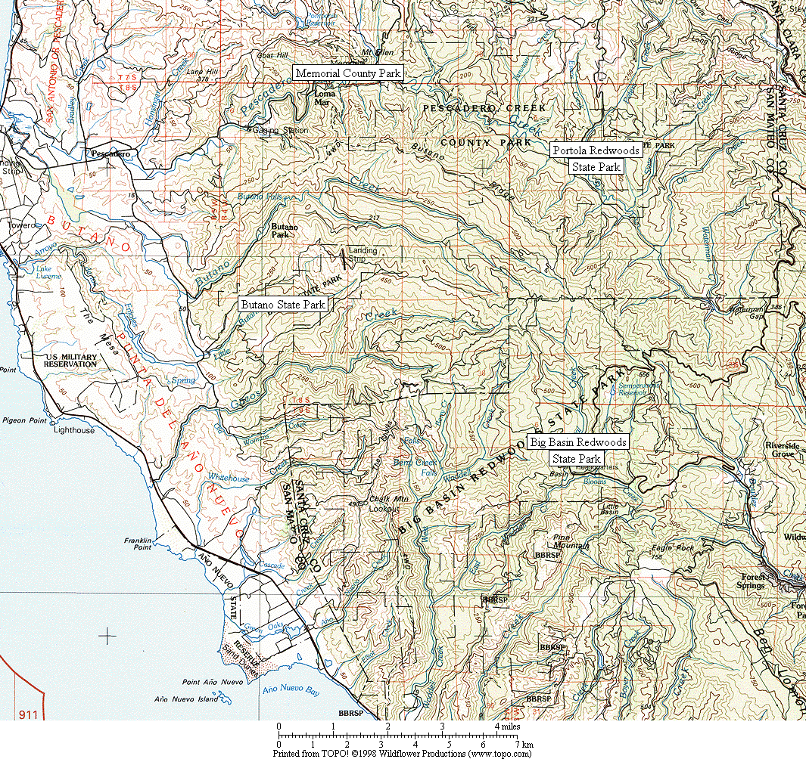

Figure 1. General location of survey areas.

Figure 2. Common Ravens have increased dramatically in all six Christmas Bird Count circles in the Santa Cruz Mountains region. (Note: data presented as a 3-year running mean.)

Figure 3. Increase in Common Raven as recorded by all six Santa Cruz Mountains region CBCs combined. (See Figure 2 for listing of individual counts.)
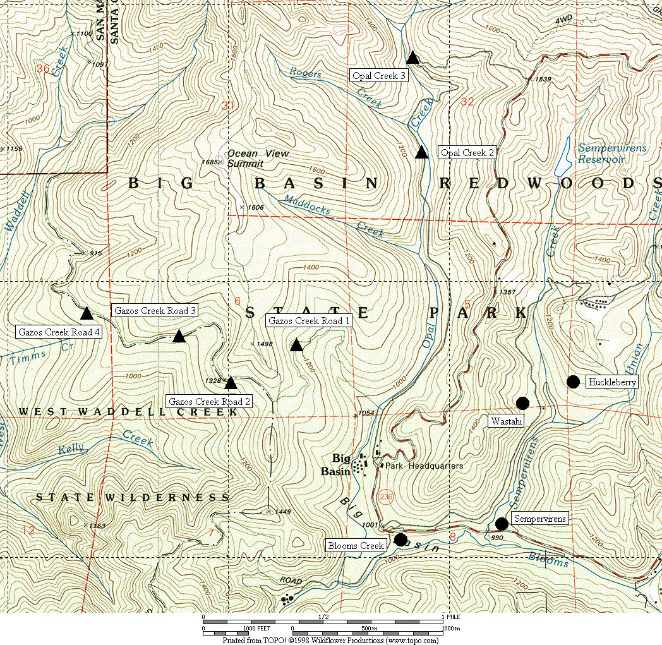

Figure 4. General location of corvid surveys area at Big Basin Redwoods State Park.
● treatment sites ▲ control sites

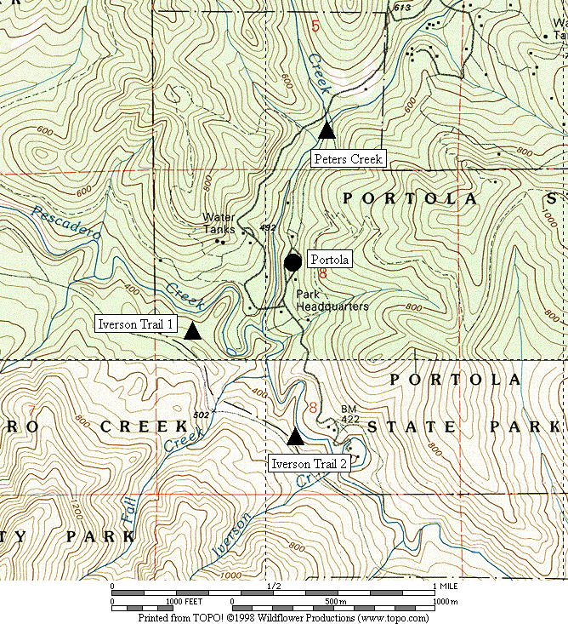

Figure 5. General location of corvid surveys area at Portola Redwoods State Park.
● treatment sites ▲ control sites

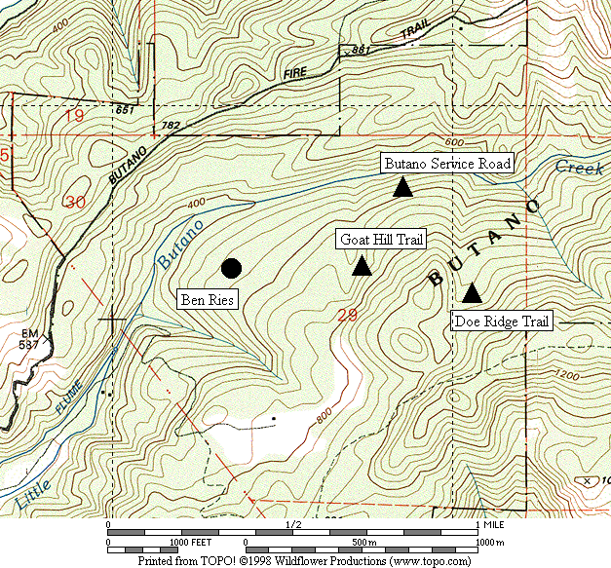

Figure 6. General location of corvid surveys area at Butano State Park.
● treatment sites ▲ control sites

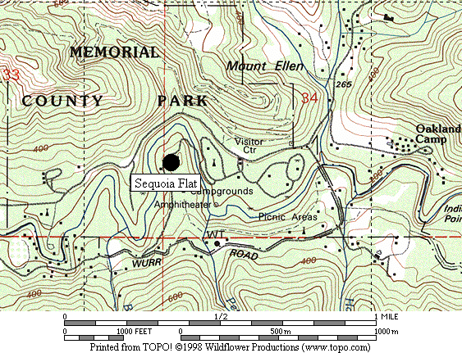

Figure 7. General location of corvid surveys area at San Mateo County Memorial Park.
● treatment site

Figure 8. Abundance of Steller’s Jay at all sites combined from 2002 to 2007.

A. Big Basin B. Portola

C. Butano D. Memorial

Figure 9. Abundance of Steller’s Jay in each park from 2003 to 2007.

Figure 10. Relative abundance of Steller’s Jays in treatment areas in each park from 2003-2007.

Figure 11. Comparison of seasonal increase in % juvenile Steller’s Jays in treatment and control areas, all parks combined (using average values from 2003-2007).

A. Treatment Areas B. Control Areas

Figure 12. Comparison of seasonal increase in number of adult and juvenile Steller’s Jays in treatment and control areas, all parks combined (using average values from 2003-2007).

A. Treament Areas B. Control Areas

Figure 13. Comparison of number of adult and juvenile Steller’s Jays in treatment and control areas, all parks combined, 2003-2007 (using adjusted raw maxima).

A. Big Basin B. Portola

C. Butano D. Memorial

Figure 14. abundance of adult and juvenile Steller’s Jay in each park from 2003 to 2007 (using adjusted raw counts).

A. Big Basin B. Portola

C. Butano D. Memorial

Figure 15. Abundance of adult Steller’s Jay in June compared to the seasonal maximum in each park from 2003 to 2007 (using adjusted raw counts).
Figure 16a. Absolute number of adult Steller’s Jays in treatment areas of each park from 2003-2007 (using adjusted raw counts).

Figure 16b. Absolute number of juvenile Steller’s Jays in treatment areas of each park from 2003-2007 (using adjusted raw counts).

Figure 17. Abundance of Common Raven at all sites combined from 2002 to 2007.

A. Big Basin B. Portola
(Note: no ravens recorded in control
areas at Portola in 2005 and 2006)

C. Butano D. Memorial

Figure 18. Abundance of Common Raven in each park from 2003 to 2007.

Figure 19. Relative abundance of Common Raven in treatment areas in each park from 2003-2007.

Appendix 1. Raw numbers of Steller’s Jays and Common Ravens on each survey, 2003-2007.

STELLER’S JAY

 | 2003 |  |  |  | 2004 |  |  |  | 2005 |  |  |  | 2006 |  |  |  | 2007
Survey Area | Run 1 | 2 | 3 | 4 | Run 1 | 2 | 3 | 4 | Run 1 | 2 | 3 | 4 | Run 1 | 2 | 3 | 4 | Run 1 | 2 | 3 | 4
Big Basin
Blooms | 25 | 47 | 57 | 93 | 27 | 18 | 47 | 36 | 22 | 48 | 43 | 53 | 18 | 44 | 68 | 85 | 17 | 27 | 46 | 25
Sempervirens | 11 | 25 | 33 | 54 | 17 | 19 | 18 | 25 | 11 | 19 | 14 | 19 | 5 | 13 | 28 | 9 | 9 | 10 | 15 | 8
Huckleberry | 41 | 45 | 48 | 102 | 48 | 39 | 23 | 32 | 27 | 26 | 39 | 37 | 12 | 34 | 41 | 58 | 27 | 33 | 53 | 19
Wastahi | 10 | 2 | 4 | 23 | 4 | 10 | 15 | 16 | 2 | 5 | 4 | 6 | 2 | 8 | 7 | 5 | 4 | 3 | 9 | 7
Opal 2 | 3 | 3 | 2 | 1 | 0 | 2 | 1 | 3 | 1 | 1 | 0 | 2 | 0 | 2 | 1 | 2 | 5 | 2 | 4 | 0
Opal 3 | 4 | 0 | 2 | 0 | 1 | 4 | 2 | 2 | 0 | 2 | 0 | 0 | 0 | 0 | 0 | 0 | 2 | 2 | 2 | 2
Gazos 1 | 4 | 4 | 3 | 1 | 2 | 2 | 1 | 1 | 1 | 3 | 0 | 0 | 2 | 4 | 2 | 2 | 0 | 2 | 3 | 1
Gazos 2 | 0 | 2 | 2 | 1 | 1 | 1 | 0 | 1 | 3 | 0 | 0 | 0 | 0 | 1 | 1 | 2 | 1 | 0 | 1 | 0
Gazos 3 | 1 | 4 | 3 | 0 | 2 | 0 | 2 | 2 | 0 | 2 | 0 | 0 | 1 | 2 | 2 | 2 | 2 | 0 | 1 | 1
Gazos 4 | 3 | 2 | 2 | 3 | 1 | 1 | 0 | 0 | 0 | 1 | 0 | 1 | 0 | 2 | 1 | 1 | 4 | 1 | 4 | 1
Portola
Portola | 7 | 24 | 24 | 37 | 28 | 19 | 20 | 23 | 17 | 16 | 30 | 27 | 17 | 21 | 27 | 21 | 9 | 11 | 19 | 22
Peters | 3 | 4 | 3 | 3 | 1 | 2 | 0 | 3 | 2 | 0 | 1 | 5 | 1 | 2 | 3 | 2 | 3 | 3 | 0 | 1
Iverson 1 | 8 | 5 | 6 | 6 | 1 | 3 | 2 | 1 | 0 | 4 | 0 | 8 | 2 | 1 | 2 | 1 | 3 | 2 | 5 | 4
Iverson 2 | 3 | 2 | 5 | 2 | 0 | 2 | 3 | 2 | 1 | 0 | 0 | 1 | 3 | 2 | 3 | 1 | 2 | 3 | 3 | 4
Butano
Ben Ries | 22 | 32 | 35 | 45 | 18 | 34 | 40 | 46 | 11 | 16 | 43 | 20 | 3 | 15 | 22 | 29 | 3 | 4 | 4 | 6
Service | 4 | 8 | 3 | 4 | 2 | 2 | 5 | 4 | 2 | 2 | 4 | 0 | 4 | 8 | 4 | 6 | 1 | 3 | 0 | 1
Goat Hill | 4 | 3 | 2 | 3 | 4 | 2 | 2 | 2 | 2 | 4 | 1 | 3 | 1 | 5 | 3 | 3 | 1 | 2 | 2 | 0
Doe Ridge | 6 | 12 | 5 | 5 | 11 | 7 | 7 | 4 | 7 | 5 | 1 | 2 | 2 | 5 | 4 | 3 | 3 | 2 | 2 | 0
Memorial
Sequoia | 46 | 71 | 107 | 179 | 46 | 79 | 136 | 133 | 36 | 76 | 161 | 142 | 25 | 42 | 48 | 93 | 23 | 61 | 68 | 104

Appendix 1, continued.

COMMON RAVEN

 | 2003 |  |  |  | 2004 |  |  |  | 2005 |  |  |  | 2006 |  |  |  | 2007
Survey Area | Run 1 | 2 | 3 | 4 | Run 1 | 2 | 3 | 4 | Run 1 | 2 | 3 | 4 | Run 1 | 2 | 3 | 4 | Run 1 | 2 | 3 | 4
Big Basin
Blooms | 3 | 3 | 0 | 0 | 2 | 2 | 2 | 2 | 2 | 0 | 0 | 2 | 1 | 2 | 0 | 2 | 2 | 4 | 4 | 2
Sempervirens | 1 | 0 | 0 | 0 | 1 | 0 | 4 | 4 | 1 | 0 | 0 | 0 | 0 | 1 | 0 | 0 | 1 | 0 | 0 | 1
Huckleberry | 3 | 3 | 3 | 3 | 2 | 3 | 2 | 4 | 2 | 2 | 5 | 1 | 3 | 5 | 4 | 1 | 4 | 5 | 5 | 0
Wastahi | 0 | 0 | 0 | 0 | 1 | 1 | 1 | 1 | 1 | 3 | 2 | 0 | 0 | 1 | 1 | 0 | 2 | 0 | 4 | 1
Opal 2 | 0 | 0 | 1 | 0 | 1 | 0 | 1 | 1 | 0 | 0 | 0 | 0 | 0 | 0 | 0 | 0 | 0 | 0 | 0 | 1
Opal 3 | 0 | 3 | 0 | 0 | 0 | 0 | 0 | 0 | 0 | 0 | 0 | 0 | 2 | 0 | 0 | 1 | 2 | 1 | 4 | 0
Gazos 1 | 0 | 0 | 0 | 0 | 0 | 0 | 0 | 0 | 0 | 1 | 0 | 0 | 0 | 1 | 0 | 1 | 0 | 0 | 0 | 0
Gazos 2 | 0 | 0 | 0 | 0 | 0 | 0 | 0 | 0 | 0 | 0 | 0 | 0 | 0 | 0 | 0 | 0 | 0 | 0 | 0 | 0
Gazos 3 | 0 | 1 | 1 | 0 | 0 | 1 | 0 | 0 | 0 | 0 | 0 | 0 | 0 | 0 | 0 | 0 | 0 | 0 | 0 | 1
Gazos 4 | 0 | 0 | 0 | 0 | 0 | 0 | 0 | 0 | 0 | 0 | 0 | 0 | 0 | 0 | 0 | 0 | 0 | 0 | 0 | 0
Portola
Portola | 0 | 4 | 3 | 3 | 1 | 5 | 4 | 2 | 1 | 0 | 0 | 0 | 2 | 2 | 3 | 1 | 1 | 3 | 4 | 2
Peters | 0 | 1 | 0 | 0 | 0 | 0 | 0 | 0 | 0 | 0 | 0 | 0 | 0 | 0 | 0 | 0 | 0 | 0 | 0 | 0
Iverson 1 | 0 | 0 | 1 | 0 | 1 | 0 | 0 | 0 | 0 | 0 | 0 | 0 | 0 | 0 | 0 | 0 | 1 | 0 | 0 | 0
Iverson 2 | 0 | 0 | 0 | 0 | 0 | 0 | 0 | 0 | 0 | 0 | 0 | 0 | 0 | 0 | 0 | 0 | 1 | 1 | 0 | 0
Butano
Ben Ries | 1 | 0 | 0 | 1 | 2 | 1 | 6 | 7 | 1 | 0 | 0 | 0 | 2 | 2 | 1 | 2 | 1 | 2 | 5 | 4
Service | 1 | 1 | 0 | 1 | 0 | 0 | 0 | 0 | 0 | 0 | 0 | 0 | 0 | 0 | 0 | 0 | 0 | 0 | 0 | 0
Goat Hill | 0 | 0 | 0 | 0 | 0 | 0 | 0 | 0 | 0 | 0 | 0 | 0 | 1 | 0 | 0 | 0 | 0 | 0 | 0 | 0
Doe Ridge | 0 | 0 | 0 | 0 | 1 | 1 | 0 | 0 | 0 | 1 | 0 | 0 | 0 | 0 | 0 | 0 | 0 | 0 | 0 | 1
Memorial
Sequoia | 2 | 3 | 4 | 5 | 7 | 5 | 7 | 5 | 5 | 5 | 9 | 2 | 2 | 3 | 0 | 0 | 7 | 4 | 5 | 7

Appendix 2. Adjusted numbers of adult and juvenile Steller’s Jays, 2003-2007.

2003 | Treatment Areas |  |  |  |  | Control Areas
Big Basin | Run 1 | Run 2 | Run 3 | Run 4 |  | Run 1 | Run 2 | Run 3 | Run 4
Adults | 87 | 108 | 120 | 152 |  | 15 | 15 | 14 | 5
Juveniles | 0 | 11 | 22 | 120 |  | 0 | 0 | 0 | 0
% Juveniles | 0.0% | 9.3% | 15.7% | 44.2% |  | 0.0% | 0.0% | 0.0% | 0.0%
Portola
Adults | 7 | 21 | 20 | 21 |  | 14 | 11 | 14 | 9
Juveniles | 0 | 3 | 4 | 16 |  | 0 | 0 | 0 | 2
% Juveniles | 0.0% | 13.0% | 18.2% | 43.3% |  | 0.0% | 0.0% | 0.0% | 14.3%
Butano
Adults | 22 | 27 | 30 | 40 |  | 14 | 23 | 10 | 10
Juveniles | 0 | 5 | 5 | 5 |  | 0 | 0 | 0 | 2
% Juveniles | 0.0% | 15.6% | 15.6% | 10.8% |  | 0.0% | 0.0% | 0.0% | 14.3%
Memorial
Adults | 46 | 65 | 88 | 128 |  | -- | -- | -- | --
Juveniles | 0 | 6 | 19 | 51 |  | -- | -- | -- | --
% Juveniles | 0.0% | 8.1% | 18.1% | 28.5% |  | -- | -- | -- | --
All Parks
Adults | 162 | 221 | 257 | 341 |  | 43 | 49 | 38 | 25
Juveniles | 0 | 25 | 51 | 192 |  | 0 | 0 | 0 | 3
% Juveniles | 0.0% | 10.1% | 16.7% | 36.1% |  | 0.0% | 0.0% | 0.0% | 11.7%
Appendix 2, continued.
2004 | Treatment Areas |  |  |  |  | Control Areas
Big Basin | Run 1 | Run 2 | Run 3 | Run 4 |  | Run 1 | Run 2 | Run 3 | Run 4
Adults | 96 | 79 | 82 | 81 |  | 7 | 8 | 6 | 9
Juveniles | 0 | 7 | 21 | 28 |  | 0 | 2 | 0 | 0
% Juveniles | 0.0% | 8.3% | 20.5% | 25.3% |  | 0.0% | 22.2% | 0.0% | 0.0%
Portola
Adults | 24 | 19 | 15 | 9 |  | 2 | 7 | 4 | 6
Juveniles | 4 | 0 | 5 | 14 |  | 0 | 0 | 1 | 0
% Juveniles | 14.3% | 0.0% | 25.0% | 58.8% |  | 0.0% | 0.0% | 20.0% | 0.0%
Butano
Adults | 18 | 32 | 30 | 36 |  | 17 | 9 | 9 | 8
Juveniles | 0 | 2 | 10 | 10 |  | 0 | 2 | 5 | 2
% Juveniles | 0.0% | 6.5% | 25.8% | 22.2% |  | 0.0% | 18.2% | 35.7% | 22.2%
Memorial
Adults | 43 | 71 | 95 | 48 |  | -- | -- | -- | --
Juveniles | 3 | 8 | 41 | 85 |  | -- | -- | -- | --
% Juveniles | 7.3% | 10.6% | 30.4% | 64.2% |  | -- | -- | -- | --
All Parks
Adults | 181 | 200 | 221 | 174 |  | 26 | 24 | 19 | 23
Juveniles | 7 | 18 | 78 | 137 |  | 0 | 4 | 6 | 2
% Juveniles | 3.9% | 8.1% | 26.0% | 43.9% |  | 0.0% | 15.1% | 24.0% | 8.9%

Appendix 2, continued.

2005 | Treatment Areas |  |  |  |  | Control Areas
Big Basin | Run 1 | Run 2 | Run 3 | Run 4 |  | Run 1 | Run 2 | Run 3 | Run 4
Adults | 62 | 83 | 82 | 30 |  | 5 | 9 | 0 | 3
Juveniles | 0 | 15 | 18 | 85 |  | 0 | 0 | 0 | 0
% Juveniles | 0.0% | 15.2% | 18.0% | 73.5% |  | 0.0% | 0.0% | #DIV/0! | 0.0%
Portola
Adults | 17 | 13 | 10 | 4 |  | 3 | 4 | 1 | 9
Juveniles | 0 | 3 | 20 | 23 |  | 0 | 0 | 0 | 5
% Juveniles | 0.0% | 18.8% | 68.0% | 84.2% |  | 0.0% | 0.0% | 0.0% | 36.4%
Butano
Adults | 11 | 16 | 28 | 10 |  | 11 | 11 | 6 | 5
Juveniles | 0 | 0 | 15 | 10 |  | 0 | 0 | 0 | 0
% Juveniles | 0.0% | 0.0% | 34.1% | 50.0% |  | 0.0% | 0.0% | 0.0% | 0.0%
Memorial
Adults | 36 | 72 | 109 | 28 |  | -- | -- | -- | --
Juveniles | 0 | 4 | 52 | 114 |  | -- | -- | -- | --
% Juveniles | 0.0% | 5.9% | 32.4% | 80.6% |  | -- | -- | -- | --
All Parks
Adults | 126 | 184 | 229 | 72 |  | 19 | 24 | 7 | 17
Juveniles | 0 | 22 | 105 | 232 |  | 0 | 0 | 0 | 5
% Juveniles | 0.0% | 10.9% | 31.5% | 76.2% |  | 0.0% | 0.0% | 0.0% | 23.1%
Appendix 2, continued.
2006 | Treatment Areas |  |  |  |  | Control Areas
Big Basin | Run 1 | Run 2 | Run 3 | Run 4 |  | Run 1 | Run 2 | Run 3 | Run 4
Adults | 37 | 91 | 102 | 34 |  | 3 | 11 | 6 | 7
Juveniles | 0 | 8 | 42 | 123 |  | 0 | 0 | 0 | 0
% Juveniles | 0.0% | 7.7% | 29.0% | 78.6% |  | 0.0% | 0.0% | 0.0% | 0.0%
Portola
Adults | 17 | 18 | 22 | 4 |  | 6 | 5 | 8 | 4
Juveniles | 0 | 3 | 5 | 18 |  | 0 | 0 | 0 | 0
% Juveniles | 0.0% | 15.0% | 19.2% | 83.3% |  | 0.0% | 0.0% | 0.0% | 0.0%
Butano
Adults | 3 | 14 | 21 | 15 |  | 7 | 17 | 11 | 8
Juveniles | 0 | 1 | 1 | 15 |  | 0 | 1 | 0 | 0
% Juveniles | 0.0% | 7.7% | 5.0% | 50.0% |  | 0.0% | 3.7% | 0.0% | 0.0%
Memorial
Adults | 25 | 35 | 42 | 18 |  | -- | -- | -- | --
Juveniles | 0 | 7 | 6 | 75 |  | -- | -- | -- | --
% Juveniles | 0.0% | 17.8% | 11.6% | 80.5% |  | -- | -- | -- | --
All Parks
Adults | 82 | 158 | 187 | 70 |  | 16 | 33 | 25 | 19
Juveniles | 0 | 19 | 54 | 230 |  | 0 | 1 | 0 | 0
% Juveniles | 0.0% | 11.0% | 22.3% | 76.8% |  | 0.0% | 1.9% | 0.0% | 0.0%
Appendix 2, continued.
2007 | Treatment Areas |  |  |  |  | Control Areas
Big Basin | Run 1 | Run 2 | Run 3 | Run 4 |  | Run 1 | Run 2 | Run 3 | Run 4
Adults | 57 | 64 | 74 | 30 |  | 14 | 7 | 10 | 4
Juveniles | 0 | 9 | 49 | 29 |  | 0 | 0 | 5 | 1
% Juveniles | 0.0% | 12.5% | 40.2% | 49.0% |  | 0.0% | 0.0% | 35.7% | 25.0%
Portola
Adults | 9 | 10 | 12 | 8 |  | 8 | 8 | 6 | 7
Juveniles | 0 | 1 | 7 | 14 |  | 0 | 0 | 2 | 2
% Juveniles | 0.0% | 10.0% | 38.9% | 61.9% |  | 0.0% | 0.0% | 25.0% | 22.2%
Butano
Adults | 3 | 4 | 4 | 5 |  | 5 | 7 | 4 | 1
Juveniles | 0 | 0 | 0 | 1 |  | 0 | 0 | 0 | 0
% Juveniles | 0.0% | 0.0% | 0.0% | 20.0% |  | 0.0% | 0.0% | 0.0% | 0.0%
Memorial
Adults | 23 | 52 | 33 | 16 |  | -- | -- | -- | --
Juveniles | 0 | 9 | 35 | 88 |  | -- | -- | -- | --
% Juveniles | 0.0% | 15.1% | 50.8% | 84.2% |  | -- | -- | -- | --
All Parks
Adults | 92 | 130 | 123 | 60 |  | 27 | 22 | 20 | 12
Juveniles | 0 | 19 | 91 | 131 |  | 0 | 0 | 7 | 3
% Juveniles | 0.0% | 13.0% | 42.7% | 68.8% |  | 0.0% | 0.0% | 27.2% | 21.7%

